Test Strategy Document
Version No: 1.0
Date: 05-03-2019
Project Name: ADDI
Project Code:

Copyright Notice
This document contains proprietary information of HCL Technologies Ltd. No part of this document may be reproduced, stored, copied, or transmitted in any form or by means of electronic, mechanical, photocopying or otherwise, without the express consent of HCL Technologies. This document is intended for internal circulation only and not meant for external distribution.

Revision History
Version No | Date | Prepared by/Modified by | Significant Changes
1.0 | 05-03-2019 | KHAJA HUSSAIN | Initial Draft

Table of Contents

1 Introduction 4
1.1 About the Client 4
1.2 About the Project 4
1.3 Application / System overview 4
2 Test Scope 4
2.1 Test objective 4
2.2 Types of tests 4
2.3 Inclusions 4
2.4 Exclusions 4
2.5 Assumptions 4
2.6 Baseline documents 4
3 Test Approach 5
3.1 Test planning methodology 5
3.2 Test Execution methodology 5
4 Resources 6
4.1 Skills required for the project 6
4.2 Training Schedule 6
4.3 Offshore 6
4.4 Onsite 6
4.5 Test infrastructure 7
5 Project Organization 7
5.1 Escalation model 7
5.2 Change Management Process 7
5.3 Suspension and Resumption criteria 7
5.4 Risk, Contingency and Mitigation Plan 8
5.5 Schedule 8
6 Reference 8
7 Annexure 8

Introduction

About the Client
DXC Technology, a company formed from the merger of Computer Sciences Corporation (CSC) and Hewlett Packard Enterprise Services. Digital cross connect system (DXC or DCS), a piece of circuit-switched network equipment, used in telecommunications networks.

About the Project

IBM® Application Discovery and Delivery Intelligence (ADDI) is an analytical platform for application modernization. It uses cognitive technologies to analyze mainframe applications, so you can quickly discover and understand interdependencies and impacts of change.

There are two components in ADDI – Application Discovery (AD) and Delivery Intelligence (DI). While Delivery intelligence provides benefits of understanding applications run time behavior, Application Discovery part provides the enterprise view of applications landscape. The (DI) component is not in scope.

Using AD part of ADDI, a customer can view in graphical format, which represents the interrelationship between the components that make up the application. More information about IBM ADDI can be found at:
https://www.ibm.com/support/knowledgecenter/en/SSRR9Q_5.0.4/IBM_AD_Analyze_User_Guide_OUT_KC/IBMADHighLevelArchitectureOverview.html
DXC clients want to use IBM ADDI (AD) to investigate and learn about Hogan application. Hogan applications don’t directly utilize native z/OS constructs in Programs, but work through PEM. PEM provides abstraction layer between underlying z/OS and Hogan application. IBM ADDI or any other tool not provided by us cannot work.

Hogan Discovery API delivered through this project will help translate these native z/OS dependencies for Hogan. IBM ADDI will call Hogan Discovery API for translation.

Application / System overview
ADDI project consists multiple API. We are preparing test cases for each API and execute
All test case in Katalon studio and capture the results from Katalon Studio.

Test Scope
The initial phase will include all ‘must have’ requirements. These and any other requirements that get included must all be tested. At the end of Phase 1, a tester must be able to:
- Create Automation test with as many steps as necessary
- Retrieve it and have the ability to view it when running the test
- Enter results and appropriate comments
- View results

As the team works with the product they will define the needs for the second phase.
Load testing will not be considered part of this project since the user base is known and not an issue.

Test objective
Test Case Tamer is a web service-based Katalon tool used to create and store tests as well as the results of running those tests. This tool is a new product written with Java. The test team is responsible for testing the product and ensuring it meets their needs. The test team is both the customer and the tester in this project.

Phase 1 of the project will deliver TCT (Test Case Tamer) with functionality to create and store Automation tests. This will allow the test team to start transferring tests over to the new system. Must have functionality is considered more important than the delivery date in this project.

Types of tests
Types of testing applicable for this project, such as Unit testing and regression testing.
API | Test Description
Activity Controller | Activity Controller json file
Ccp Controller | Ccp Controller json file
Definition Group Controller | Definition Group Controller json file
Fps Controller | Fps Controller json file
Map Controller | Map Controller json file
Program Controller | Program Controller json file
Sdb Controller | Sdb Controller json file
Sim Controller | Sim Controller json file
Sps Controller | Sps Controller json file
Transaction Controller | Transaction Controller json file
Json Controller | Json Controller json file

Exclusions
N/A

Assumptions
Test engineer responsible for testing the project. Then the Assumption is that all API unit test cases are executed and integrating testing also covered.

Baseline documents
N/A

Test Approach

Test planning methodology

Entry criteria
Entry criteria for testing can be defined as “Specific conditions or on-going activities that must be present before a process can begin”. The Software Testing Life Cycle (STLC) specifies the entry criteria required during each testing phase. It also specifies the time interval or required amount of lead time to make the entry criteria item available to the process. The inputs can be divided into two categories – inputs received from development and inputs produced from the test phases at the end of STLC.

- Defined and Approved Requirements
- Test Plan
- Test Cases and Test Data
- Test Tools
- Testable Code with Appropriate Test Environment

Approach
The project is using an agile methodology approach, with weekly iterations. At the end of each week the requirements identified for that iteration will be delivered to the team and will be tested.

Test documents
Test document is Excel document this contains all API test cases and all defects of API.

Test Execution methodology

Entry criteria
Entry criteria for testing can be defined as “Specific conditions or on-going activities that must be present before a process can begin”. The Software Testing Life Cycle (STLC) specifies the entry criteria required during each testing phase. It also specifies the time interval or required amount of lead time to make the entry criteria item available to the process. The inputs can be divided into two categories – inputs received from development and inputs produced from the test phases at the end of STLC.

- Defined and Approved Requirements
- Test Plan
- Test Cases and Test Data
- Test Tools
- Testable Code with Appropriate Test Environment
- Execute the test cases and capture the results.

Test data generation
Details of data needs for the test, we will generate test data for each API based on client requirement and we will use that data in each test script. We will perform test execution.

Test iterations
Number of API are testing planned for execution.

Item to Test | Test Description
Activity Controller | Activity Controller json file
Ccp Controller | Ccp Controller json file
Definition Group Controller | Definition Group Controller json file
Fps Controller | Fps Controller json file
Map Controller | Map Controller json file
Program Controller | Program Controller json file
Sdb Controller | Sdb Controller json file
Sim Controller | Sim Controller json file
Sps Controller | Sps Controller Json file
Transaction Controller | Transaction Controller Jason file
Json Controller | JSON Controller Json file

Defect Management
The defect management process for this project will be explained in this section. It will include defect meeting, defect resolution, etc.

Defect Logging & Defect Reporting
Defect logging will be primarily done by Test engineers. However, others (developers, Tech leads, architects and PM) will also be able to log the defects. Defect logging process and defect log template that will be used during the execution. Re-testing the defect and close the defect.

Defect Classification & Defect Life cycle
Defect initially when logged will be ‘Open’ state and get to ‘Assigned’ state when assigned to a developer, ‘Resolved’ when defect is corrected and sent back for re testing and finally ‘closed’ by the test resource after verification. Defect state can be changed to ‘Reopened’ if modified code did not resolve the defect.

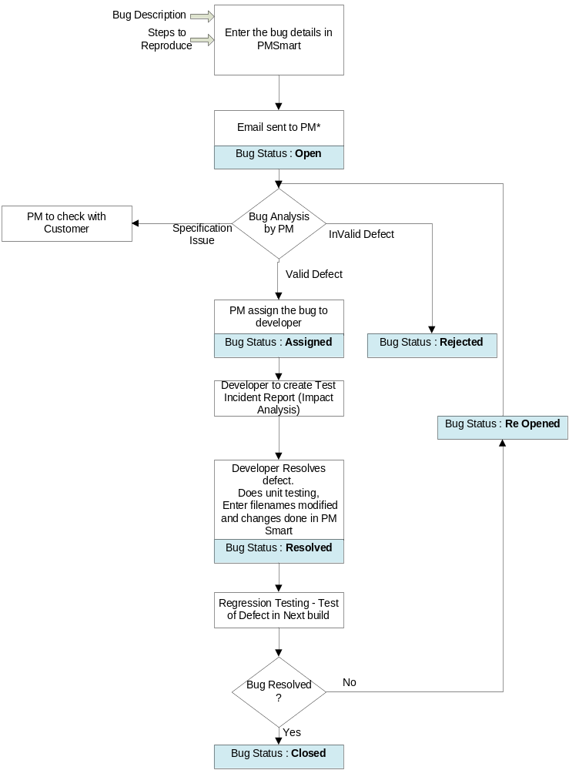

Defect Meeting
Detailed defect meeting is held with the development / defect fix team to rationalize and authenticate the reported defects. Detailed defect meeting procedure indicating the list of likely participants to the defect meeting.

Exit criteria

Exit criteria in testing are often viewed as a single document commemorating the end of a life cycle phase. It can be defined as “The specific conditions or on-going activities that should be fulfilled prior to completing the software testing life cycle.

The following exit criteria should be considered for completion of a testing phase:
- Ensuring all critical Test Cases are passed
- Achieving complete Functional Coverage
- Executing the major functional/business flows successfully by leveraging various test inputs and ensuring that they are working fine
- Identifying and fixing all the high-priority defects
- Fixing all the ‘Show Stopper defects’ or ‘Blockers’ and ensuring that none of the identified Critical/Severity 1 defects are in Open Status
- Re-testing and closing all the high-priority defects to execute corresponding Regression scenarios successfully

The following output is achieved through the exit criteria:
- Test Logs
- Test Incident Report Log
- Test Summary Report/Findings Report

Resources

Skills required for the project
Katalon Studio experience and bug tracking toll experience required for this ADDI project.

Training Schedule
Resource need to get training for Katalon Studio and Defect tracking tool.

Offshore

Test personnel
N/A

Roles & Responsibilities HCLT
Analyzing the SRS or BRS document for the application and prepare the test cases for each API. Prepare the test data and implementing the data driven testing for each API and run the unit test cases and regression testing. Capture the results for each API and send it to the concern persons. If any failure test case is identified logging to the defect in excel sheet and report to developers. Once developers are fixed the defect re-testing all test cases /defects. Once defects are fixed closed the defects.

Onsite

Test personnel
N/A

Roles & Responsibilities

N/A

Test infrastructure

Test environment
Hardware
Hardware / Software | Make /Model | Details | Remarks
Laptops/Desktops | HP/Lenovo

Software
Hardware / Software | Make /Model | Details | Remarks
Katalon Studio | 5.10.1

Connectivity
N/A

Project Organization

Escalation model
In case of issues and concerns, the escalation procedure and time lines to escalate Pallavi Gupta.

Change Management Process
N/A

Suspension and Resumption criteria
The criteria used to suspend and resumption all or portion of the testing activity on the test item. This situation arises in conditions like crashes and loss of major functionality during testing.
The testing activities, which must be repeated, when testing is resumed. Following can be considered as guidelines
- Encountering showstopper at the application level or a show stopper at API level which is critical for the functioning of the application
- On transfer of wrong soft base
- On failure of test environment
- Any other circumstances or situation when the test team is convinced that the testing cannot be continued
- On request from customer
- On resolving the situation, which resulted in the suspension
- On specific request of the Customer on record mentioning the alleviating condition(s) allowing HCLT to proceed.

Risk, Contingency and Mitigation Plan
The following risks have been identified and the appropriate action identified to mitigate their impact on the project. The impact (or severity) of the risk is based on how the project would be affected if the risk was triggered. The trigger is what milestone or event would cause the risk to become an issue to be dealt with.

Risk | Impact | Trigger | Mitigation Plan
As testers become more familiar with Katalon Studio tool and java they will want more functionality | High | Delays in implementation date | Each iteration, functionality will be closely monitored. Priorities will be set and discussed by stakeholders. Since the driver is functionality and not time, it may be necessary to push the date out.
Changes to the functionality may negate the tests already written and we may loose test cases already written | High – to schedule and quality | Loss of all test cases | Export data prior to any upgrade, massage as necessary and re-import after upgrade.
Weekly delivery is not possible because the developer works off site | Medium | Product did not get delivered on schedule

Schedule

Milestones
N/A

Deliverables
- Test Plan
- Test Cases
- Test Scripts
- Bug Reports
- Test Reports
- Requirement Traceability Matrix
- Test Strategy (this document itself)
- Customer Sign Off

Reference
N/A

Annexure
N/A

